First name
Please provide only the first name of the student/team member. Do not include middle or last names.
CREST Award Level | GOLD
Project title | Deep Fake Detection System
Mentor or supervisor name  (if you had one) | Raushan Kumar
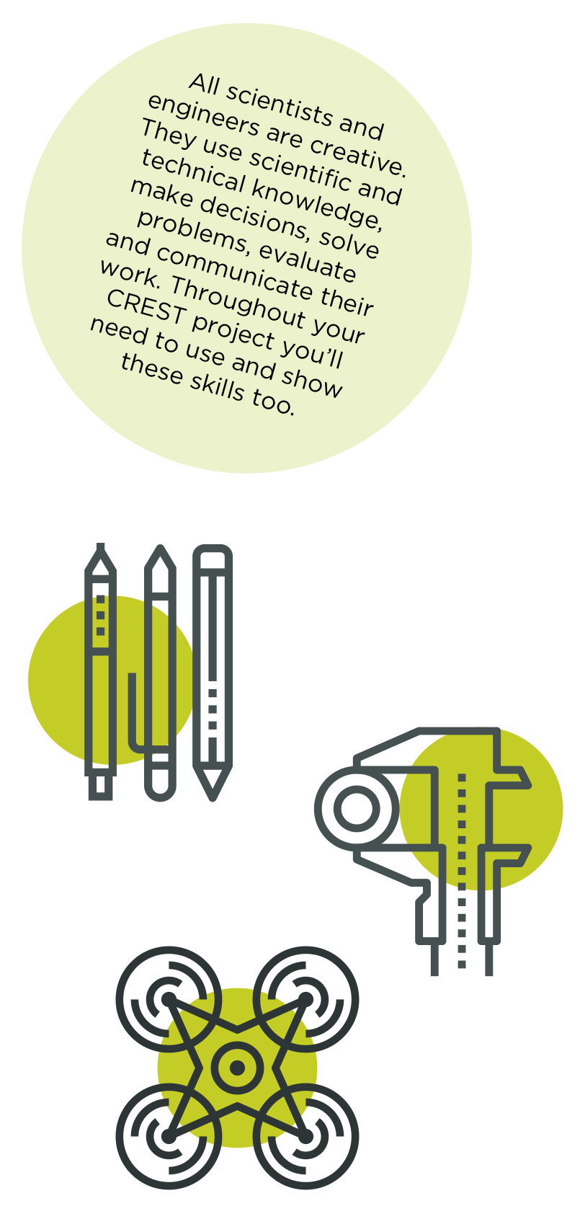

This Profile form is suitable for CREST Bronze, Silver and Gold Awards. Always use in conjunction with corresponding Student Guide Documents.

Please fill in this profile form and submit it along with your project work. This a requirement for your submission and an opportunity for you to present clearly to the assessor how you have met the CREST criteria and reflect in your project.

If you are working in a group, make sure that you fill in and submit a separate Student Profile Form for each individual.

Criteria | Where do you show this in your report or project record? | Your notes to the assessor (optional)

1 – Planning your project

1.1 You have set a clear aim for the project and have broken it down into smaller objectives | Pages 5 - Section 1.1 (Aim) and 1.2 (Objective)(5-8) | Clear aim to develop real-time AI-assisted Deepfake Detection System. Broken into specific objectives: dataset acquisition, model training for deepfake detection, validation, and web deployment.
1.2 You have explained a wider purpose for the project | Pages 2 - Section 1.3 (Wider Purpose of Project)(8-9) | It aligns with the United Nations SDG 16: Promote peaceful and inclusive societies, provide access to justice, and build accountable institutions. It also upholds UN Human Rights Council resolutions on digital integrity by safeguarding the authenticity of online content and reinforcing access to truthful information.
1.3 You have identified a range of approaches to the project | Pages 1 - Section 2.1 (Overview of Approach)(10) | Evaluated Classical Techniques, machine learning with handcrafted features, and deep learning approaches. Justified selection of deep learning for accuracy, scalability, and real-time performance.
1.4 You have described your plan for the project and why you chose that approach | Pages 3 - Section 2.1 and methodology overview, pages 11-13 : model architecture selection | Innovative model pipeline: MobileNetV2 architecture for Deepfake detection. Inspired by its high Performance on standard benchmarks and chosen for lightweight, real-time deployment.
1.5 You have planned and organized your time well | Pages 3 (12-13) Section 2.2 (Gantt Chart) and 2.3 (Project Plan with Timeline) | Comprehensive 12-week timeline with task dependencies, skill requirements, and resource allocation. Clear milestones from literature review to final deployment.

2 – Throughout your project

2.1 You have made good use of the materials and people available | Pages 3, 16-18, Acknowledgement, Section 4 (Data Collection). | I have utilized opensource dataset such as 140K real and fake dataset for this research.
2.2 You have researched the background to the project and acknowledged your sources appropriately | Page 14-15(2 pages) - Section 3 (Background Research) and Pages 43-45 References | Comprehensive literature review covering Misinformation and Communication Challenges and, Technical Challenges in Deepfake Detection, Dataset and Resource Limitations, Dataset Applications and Social Impact and Current Research Trajectory. 12 properly cited academic references spanning deepfakes and technical domains.

3 – Finalising your project

3.1 You have made logical conclusions and explained the implications for the wider world | Page 27 – section 8.2, Page 31- section 8.7, Page 32 - Section 9 (Discussion and Conclusion) Page 41- | Comprehensive analysis of the implications of challenges and logical conclusions made for the Deepfake detection project. Logical conclusions: system can support people in resource-constrained environments, bridging digital forensics gaps where access to expert analysts is limited in rural areas, enable cost effective approach. Acknowledged limitations and need for diverse datasets for global deployment.
3.2 You have explained how your actions and decisions affected the project’s outcome | Pages 26- 31 Section 8 (Training strategy revision) | Detailed analysis of initial saturated problem, systematic identification of causes, and implementation of revised training strategy with adaptive learning rates and early stopping mechanisms.
3.3 You have explained what you have learnt and reflected on what you could improve | Page 43 - Section 11 (Reflections on Learning and Improvement), Page 34-40 – detailed reflection split into what I did, why it mattered, and outcome. | Gained comprehensive skills across the entire deepfake detection pipeline, evolving from simple binary classifiers to a sophisticated two-phase MobileNetV2 framework with Grad-CAM explainability. Reflected critically on key decisions—progressive unfreezing for transfer learning, integration of explainability methods, and modular design—that had the greatest impact on performance, interpretability, and practical deployment.

4- Project-wide criteria

4.1 You have shown understanding of the science behind your project, appropriate to the Award level | Pages 14-15 (Background Research), Pages 22-24(Model Architecture), Pages (Transfer Learning), pages 24-25 (identification of performance saturation, and steps to reduce it), pages 31-40 (model results analysis) | Deep understanding spanning various Deepfake detection methods and technical domains in Deep learning models such as mobilenet ,EfficientNet,densenet , transfer learning principles. Mathematical formulations for performance metrics and Grad-CAM analysis.
4.2 You have made decisions to direct the project, taking account of ethical and safety issues | Pages 18-19 Section 4.4 (Ethics and Data Privacy), pages 38-40 | Comprehensive ethical procedures using exclusively public DeepFake datasets, secure encrypted transmission, permanent deletion of user content, transparent limitations communication, and responsible AI deployment.
4.3 You have shown creative thinking | Page 16, Pages 19-20 (Data augmentation), Pages 22-24 (MobileNetV2 model architecture), Pages 29-30 (Advanced learning rate scheduling, Early Stopping Techniques.) | Novel augmentation strategies preserving authenticity, As well as creatively taking inspiration from MobileNetV2 model for Deepfake Detection
4.4 You have identified and overcome problems successfully | Pages 26-27 – initial model saturation identification and solution. | Systematic problem-solving demonstrated: identified model saturation through training curve analysis, analyzed root causes (staged transfer learning bottleneck), implemented multi-faceted solution combining architectural changes, regularization techniques, and unified training approach and transfer learning unfreezing at epoch 25.
4.5 You have explained your project clearly, in writing or conversation | Pages 5-9(Introduction and project setup), Page 34-40 (Deployment interface), Entire document structure and technical explanations | Clear technical communication with appropriate deepfake terminology and AI terminology. Logical document structure with effective figures, tables, and visualizations. Comprehensive methodology explanations suitable for both technical and forensic community. Complete pipeline documentation from raw data to deployed web interface.

Personal reflections
Now that you’ve finished your project, use this space to add further thoughts on what you did and evaluate each stage of the project process. The CREST Gold Award student guide gives an example of what to include. You can continue on a separate sheet if necessary and use diagrams or pictures if you want to.
- How my project was successful/not successful
- What I learned
- What impact the results of my project might have on other people/the wider world
- What I would have done to improve my work
- What I’d do to develop the project in the future
I feel that I have meaningfully contributed to the understanding of deepfake detection using MobileNetV2 architecture and its development across various training phases. I have further enriched myself in the domain of technical skills, expertise with various tools and techniques for synthetic media authentication from input image data. I've further explored integrating deepfake detection with advanced available AI tools and explainability frameworks.
To this end, I have provided a roadmap of applying transfer learning techniques and integrated tools for binary classification with input images. Data and information have been collected based on expert recommendations in computer vision and media forensics. Additionally, I have analyzed training curves and performance metrics and concluded that deepfake detection can be quite helpful for countries like India where digital misinformation affects millions through manipulated content on social media platforms.
However, if I have to reflect back on my experience, I do see areas where perhaps I could have done better. One critical aspect is stakeholder engagement with digital forensics experts and content moderators. Though I conducted thorough technical analysis with the 140k deepfake dataset and successfully achieved 99.89% validation accuracy with deployment-ready performance, I was not able to directly engage with forensic investigators during the model development process, which would have enriched the understanding of practical authentication needs and real-world deployment challenges.
This would have provided an opportunity for a more comprehensive understanding of the challenges and possible solutions, particularly those motivated by emerging deepfake generation techniques and the diverse attack vectors across different social media platforms. While the MobileNetV2 model performed excellently and was successfully deployed via Flask web application, the need for continuous adaptation to new deepfake methods suggests fundamental challenges that technical optimization alone cannot address. Second, I could have expanded the research scope to investigate adversarial robustness and cross-dataset generalization across different deepfake generation frameworks.
All these factors would be given priority if I were to undertake this research again. In order to ensure a much more holistic and stakeholder-centered approach, I would pay greater attention to engagement with forensic community representatives and integrate their perspectives into the research design process. Recognizing that emerging generation techniques significantly affect detection performance, I would conduct deeper assessments of adversarial attacks and model robustness. Through this approach, I believe I could develop more practically effective solutions that address the authentication needs of diverse digital forensics applications, rather than achieving deployment success only on controlled benchmark datasets.
Moreover, my learning can be assessed and corroborated in the form of:
Technical Skills - Dataset acquisition and preprocessing, train-test-validation splits, two-phase transfer learning implementation, model inference optimization, and Flask web deployment with Grad-CAM integration.
Application of Knowledge - Successfully leveraging theoretical concepts in computer vision and transfer learning to address real-world synthetic media detection challenges. This involved translating advanced convolutional neural network architectures and explainable AI theory into practical solutions, achieving deployment-ready performance on benchmark datasets (99.89% validation accuracy, 99.87% test accuracy) while maintaining computational efficiency for real-time applications.
Research Skills - Incorporating state-of-the-art machine learning models and explainability techniques for real-time deepfake detection, implementing comprehensive evaluation frameworks, and developing modular, scalable architectures suitable for forensic deployment.

My mentor or supervisor
If you had a project mentor or placement supervisor (such as a teacher, relative, industry expert, etc.) how did they help with your project? (Please leave blank if you did not have one.)
Both of my mentors helped me collect 140k real and fake data. Mr. Raushan Kumar is the Faculty of Maths at Pace IIT & Medical Pvt Ltd. He helped shape my project directing me in the right direction. Not only did he help me collect data ,he suggested innovative solutions that I was able to apply and finally helped me achieve the best possible solutions which helped me answer the questions and apply the robust model possible for the project.
Mr. Tharun has been extremely helpful with this project. Not only did he help me collect 140k real and fake data but helped me express this as graphs and various comparative outcomes. He helped me analyze data and reach suitable conclusions with the data that I was given. Moreover, he ensured that I had a deep understanding of the subject and corrected any fallacies I had towards the subject. He suggested innovative solutions that I was able to apply and finally helped me achieve the best possible solutions which helped applying the possible model for Deep Fake Detection.
Moreso, their wholesome guidance can be corroborated in the form of :-
- Technical Guidance: They and along with his team shared their expertise on AI-based technologies for data preprocessing, model selection, model training and finally model inference.
- Inspiring Innovative Thinking: My mentor encouraged me to explore creative solutions, such following as model optimization techniques , data imbalance techniques and ensuring that the pipeline delivers for real time usage.
- Structuring My Research: They assisted me in organizing my research into clear phases, from conducting literature reviews to performing experiments and completing techno-economic analysis. Their input ensured that I followed a logical progression and addressed all critical aspects of AI-based Detection system.
- Offering Industry Insights: They helped me connect my findings to real-world industry trends and challenges.
- Reviewing and Improving My Work: They regularly reviewed my findings, gave me constructive feedback, and helped me refine my experimental setups and analysis. They also worked with me to improve the clarity and performance of my final report.
Ask your mentor or supervisor to confirm this project is your work by signing below.

Signature of mentor or supervisor
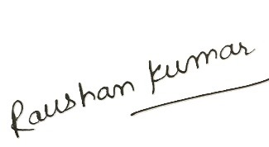 Date 25th July 2025
Space for further notes/ drawings/ reflections (optional)...

